# Import a Custom Report Layout in ForNAV Cloud

Open Business Central. Go to Custom Report Layouts.

Select New. In the window that opens enter the report ID and select Insert Word Layout.

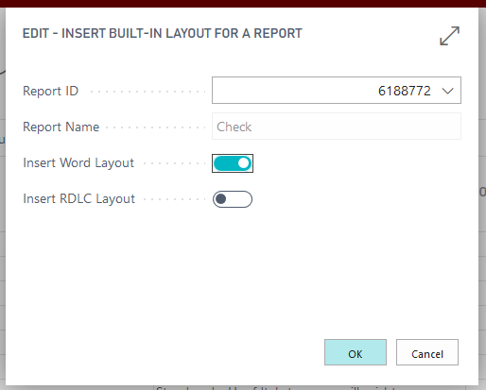

Rename the Custom Report Layout to something Recognizable.

Select the Custom Report Layout that was created and select Actions > Import Layout

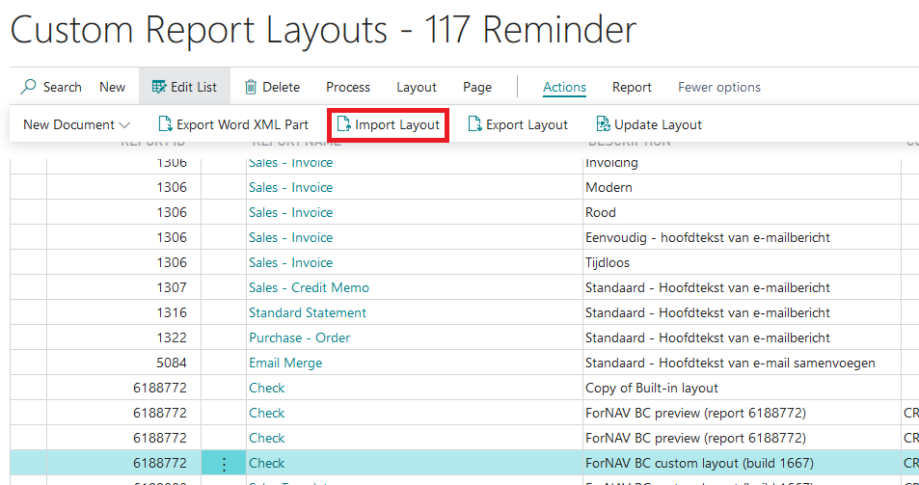

In the Select File dialog box that appears select the docx file you want to import.

In Business Central open the Report Layout Selections

In the field Custom Layout Description select the new Custom Report Layout you just created.

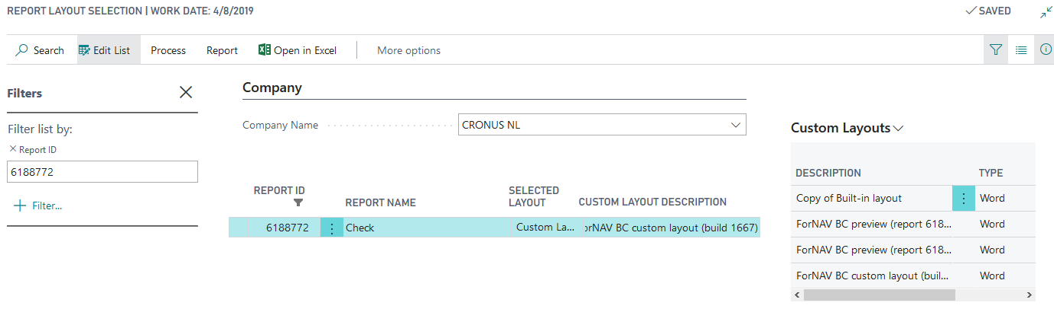

# Export a ForNAV layout in ForNAV cloud

Open Business Central. Go to Custom Report Layouts.

Select the Layout you want to export and select Actions > Export

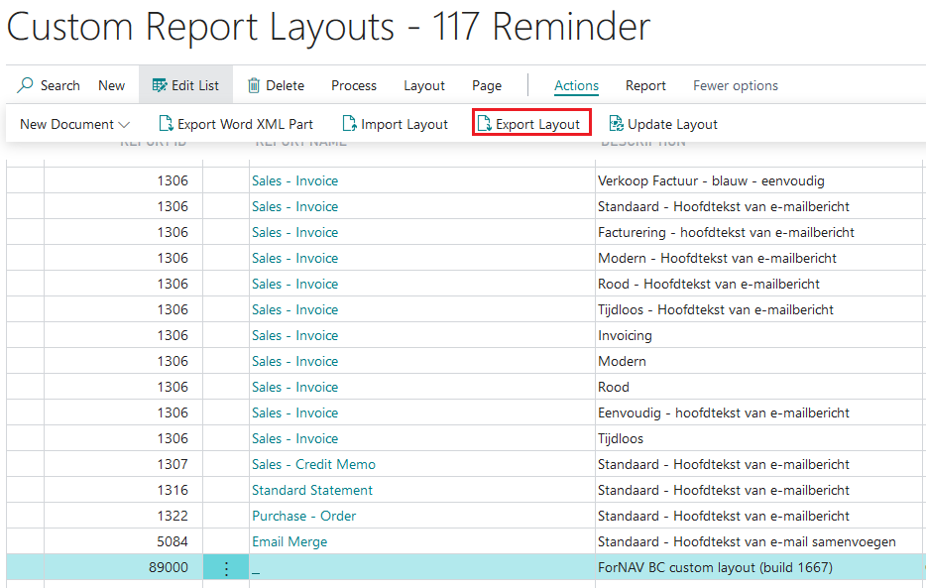

Save the resulting docx file.

If you want to edit the layout docx file open the ForNAV designer, select open and find the docx file.